CD LAB Manual (R22) B.Tech CSE IV.I SEM

Ex.No : 1
4

IMPLEMENTATION OF SYMBOL TABLE

AIM:
To write a C program to implement Symbol Table.

ALGORITHM:
- Start the program for performing insert, display, delete, search and modify option in symbol table
- Define the structure of the Symbol Table
- Enter the choice for performing the operations in the symbol Table
- If the entered choice is 1, search the symbol table for the symbol to be inserted. If the symbol is already present, it displays “Duplicate Symbol”. Else, insert the symbol and the corresponding address in the symbol table.
- If the entered choice is 2, the symbols present in the symbol table are displayed.
- If the entered choice is 3, the symbol to be deleted is searched in the symbol table. If it is not found in the symbol table it displays “Label Not found”. Else, the symbol is deleted.
- If the entered choice is 5, the symbol to be modified is searched in the symbol table. The label or address or both can be modified.

PROGRAM:

#include<stdio.h> #include<conio.h> #include<stdlib.h> #include<string.h> struct table
{
char var[10]; int value;
};
struct table tbl[20]; int i,j,n;
void create(); void modify();
int search(char variable[],int n); void insert();
void display(); void main()
{
int ch,result=0; char v[10]; clrscr();
do
{
printf("Enter your choice\n1.Create\n2.Insert\n3.Modify\n4.Search\n5.Display\n6.Exit:"); scanf("%d",&ch);
switch(ch)
{
case 1:

case 2:

case 3:

case 4:

create(); break;

insert(); break;

modify(); break;

printf("Enter the variable to be searched for:\n"); scanf("%s",&v);
result=search(v,n); if(result==0)
printf("The variable does not belong to the table\n"); else

5
printf("The location of the variable is %d\nThe value of %s is
%d\n",result,tbl[result].var,tbl[result].value); break;

}
while(ch!=6);
getch();
}
case 5:

case 6:

}

display(); break;

exit(1);
void create()
{
printf("Enter the no. of entries:"); scanf("%d",&n);
printf("Enter the variable and the value:\n"); for(i=1;i<=n;i+
+)
{
scanf("%s%d",tbl[i].var,&tbl[i].value); check: if(tbl[i].var[0]>='0'&&tbl[i].var[0]<='9')
{

}
check1:
printf("The variable should start with an alphabet\nEnter correct variable name:\n"); scanf("%s%d",tbl[i].var,&tbl[i].value);
goto check;
for(j=1;j<i;j++)
{
if(strcmp(tbl[i].var,tbl[j].var)==0)
{
printf("The variable already exists.Enter another variable\n"); scanf("%s
%d",tbl[i].var,&tbl[i].value); goto check1;
}
}
}
printf("The table after creation is:\n"); display();
}
void insert()
{
if(i>=20)
printf("Cannot insert.Table is full\n");
else
{
6
n++;
printf("Enter the value and variable\n"); scanf("%s%d",tbl[n].var,&tbl[n].value); check: if(tbl[i].var[0]>='0'&&tbl[i].var[0]<='9')
{

}
check1:
printf("The variable should start with an alphabet\nEnter correct variable name:\n"); scanf("%s%d",tbl[i].var,&tbl[i].value);
goto check;
for(j=1;j<n;j++)
{
if(strcmp(tbl[j].var,tbl[i].var)==0)
{
printf("The variable already exist.Enter another variable\n"); scanf("%s
%d",tbl[i].var,&tbl[i].value); goto check1;
}
}
printf("The table after insertion is:\n"); display();
}
}
void modify()
{
char variable[10]; int result=0;
printf("Enter the variable to be modified\n"); scanf("%s",&variable); result=search(variable,n);
if(result==0)
printf("%s does not belong to table\n",variable);
else
{

printf("The current value of the variable %s is %d\nEnter the new variable and its value\n",tbl[result].var,tbl[result].value); scanf("%s
%d",tbl[result].var,&tbl[result].value); check: if(tbl[i].var[0]>='0'&&tbl[i].var[0]<='9')
{
printf("The variable should start with an alphabet\nEnter correct variable name:\n"); scanf("%s%d",tbl[i].var,&tbl[i].value);
goto check;
}
}
printf("The table after modification is:\n"); display();
7
}
int search(char variable[],int n)
{
int flag; for(i=1;i<=n;i+
+)
{
if(strcmp(tbl[i].var,variable)==0)
{
flag=1; break;
}
}
if(flag==1)
return i;
else

}

return 0;
void display()
8
{
printf("VARIABLE\t VALUE\n"); for(i=1;i<=n;i++)
printf("%s\t\t%d\n",tbl[i].var,tbl[i].value);
}

OUTPUT

Enter your choice 1.Create
- Insert 3.Modify 4.Search 5.Display 6.Exit:1
Enter the no. of entries:3 Enter the variable and the value: AIM 45
ASK 34
BALL 56
The table after creation is: VARIABLE VALUE
AIM 45
ASK 34
BALL 56
Enter your choice 1.Create
- Insert 3.Modify 4.Search 5.Display 6.Exit:2
Enter the value and variable SIM 25
The table after insertion is:
VARIABLE  AIM | VALUE | 45
ASK |  | 34
BALL |  | 56
SIM |  | 25
Enter your choice 1.Create
2. Insert 3.Modify 4.Search 5.Display
6.Exit:3

Enter the variable to be modified ASK
The current value of the variable ASK is 34
9

Enter the new variable and its value RIM 40
RESULT:
Thus the C program to implement Symbol Table was executed and verified successfully.
10

The table after modification
is: VARIABLE  AIM | VALUE | 45
RIM |  | 40
BALL |  | 56
SIM |  | 25
Enter your choice 1.Create
2. Insert 3.Modify 4.Search 5.Display
6.Exit:4

Enter the variable to be searched for: RIM
The location of the variable is 2 The value of RIM is 40

Enter your choice
1.Create
2.Insert
3.Modify
4.Search
5.Display
6.Exit:5
VARIABLE | VALUE
AIM | 45
RIM | 40
BALL | 56
SIM | 25
Enter your choice
1.Create
2.Insert
3.Modify
4.Search
5. Display 6. Exit:6

Ex.No :2 DATE:

DEVELOPMENT OF LEXICAL ANALYSER

AIM:
To develop a lexical analyzer to recognize a few patterns in C.

ALGORITHM:

- Open the input file in read mode.
- Read the string from file till end of file.
- If the character is a slash, then call skip comment () for skip the comment statements in the file.
- If the first string matches with any delimiters operator, then print as a delimiter.
- If the first string matches with any header, then print that string as a header file.
- If the first string matches with any operator, then print that as an operator.
- If the first string matches with any keywords, then print that string as a keyword.
- If the string is not a keyword, then print that as an identifier.

PROGRAM:
/* This program is for creating a Lexical Analyzer. lexical.c */ #include<stdio.h>
#include<string.h> //Necessary Header files
#include<conio.h> #include<ctype.h>
FILE *fp; //File pointer for accessing the file
char delim[14]={‘ ‘,’\t’,’\n’,’,’,’;’,’(‘,’)’,’{‘,’}’,’[‘,’]’,’#’,’<‘,’>‘};
char oper[7]={‘+’,’-’,’*’,’/’,’%’,’=‘,’!’};//Array holding all the operators

/* Set of Keywords to check and list out */
char key[21][12]= {“int”,”float”,”char”,”double”,”bool”,”void”,”extern”,”unsigned”,”goto”,
”static”,”class”,”struct”,”for”,”if”,”else”,”return”,”register”,”long”,”while”,”do”};

/*The Preprocessor directives*/
char predirect[2][12]={“include”,”define”};

/*The possible header files*/ char header[6]
[15]={“stdio.h”,”conio.h”,”malloc.h”,”process.h”,”string.h”,”ctype.h”}; void skipcomment(); //Function to skip comments.
void analyze(); //Function analyzing the input file
void check(char[]); //Function to check whether the string matches any of the keywords int isdelim(char); //Function to check if the character retrieved from the file is a delimiter int isop(char); //Function to check if the character retrieved from the file is an operator
int fop=0,numflag=0,f=0; //necessary flag values
char c,ch,sop; //necessary character variables to store the characters retrieved

void main() //Main Function
{
char fname[12]; clrscr();
printf(“\nEnter filename : “); scanf(“%s”,fname); fp=fopen(fname,”r”); //Opening the file
if(fp==NULL) //Checking Existence of the File
printf(“\nThe file doesn’t exist.”);

12
else //If Check succeeds
analyze(); printf(“\ nEnd of file\n”); getch();
} //End of Main function

void analyze() //Analyse Function
{
char token[50]; //Declare a token character array
int j=0;
while(!feof(fp)) //While the file is not over
{
c=getc(fp);
if(c==‘/’) //checking for comments in the file
{
skipcomment(); //Function to skip comment statements
}
else if(c==‘“‘) //Skipping printf statements and other such display
while((c=getc(fp))!=‘“‘);
else if(isalpha(c)) //checking if the character is an alphabet or not
{
if(numflag==1)
{

}
else
{

}
if(f==0)
token[j]=‘\0’; check(token); numflag=0; j=0;
f=0;

token[j]=c; //Combining the characters to get the token
j++;
f=1;
}
13
else if(isalnum(c))
{

}
else
{
if(numflag==0)
numflag=1;
token[j]=c;//combining the characters to get the token
j++;

if(isdelim(c)) //Checking for delimiters.
{
if(numflag==1)
{
token[j]=‘\0’; check(token); numflag=0;
}
if(f==1)
{
token[j]=‘\0’; numflag=0; check(token);
} j=0; f=0;
printf(“\nDelimitter\t %c”,c);
}
else if(isop(c)) //Checking for operators
{
if(numflag==1)
{
token[j]=‘\0’; check(token); numflag=0; j=0;
f=0;
}
14
if(f==1)
{

}
if(fop==1)
{
token[j]=‘\0’; j=0;
f=0;
numflag=0; check(token);

fop=0;
printf(“\nOperator\t %c%c”,c,sop); //In case the operator is like ‘++’or ‘--
}
else
printf(“\nOperator\t %c”,c); //In other cases.
}
else if(c==‘.’)
{
token[j]=c; j++;
}
}
}
}

int isdelim(char c) //Function to check if the character retrieved from the file is a delimiter.
{
int i; for(i=0;i<14;i++)
{
if(c==delim[i])
return 1;
}
return 0;
}

int isop(char c) //Function to check if the character retrieved from the file is an operator.
15
{
int i,j; char ch;
for(i=0;i<7;i++)
{
if(c==oper[i])
{
ch=getc(fp);
for(j=0;j<6;j++) //In case the operator is like ‘++’ or ‘--’, etc.
{
if(ch==oper[j])
{
fop=1; sop=ch; return 1;
}
}
ungetc(ch,fp); return 1;
}
}
return 0;
}
void check(char t[]) //Function to check if the token is an identifier, keyword, header file name
{
int i; if(numflag==1)
{
printf(“\nNumber\t\t %s”,t); return;
}
for(i=0;i<2;i++)
{
if(strcmp(t,predirect[i])==0)
{
printf(“\nPreprocessor directive %s”,t); return;
16
}
}
for(i=0;i<6;i++)
{
if(strcmp(t,header[i])==0)
{
printf(“\nHeader file\t %s”,t); return;
}
}
for(i=0;i<21;i++)
{
if(strcmp(key[i],t)==0)
{
printf(“\nKeyword\t\t %s”,key[i]); return;
}
}
printf(“\nIdentifier\t %s”,t);
}

void skipcomment() //Function to skip over the comment statements in the file.
{
ch=getc(fp);
if(ch==‘/’) //Checking single line comments
{
while((ch=getc(fp))!=‘\n’);
}
else if(ch==‘*’) //Checking multiple line comments.
{
while(f==0)
{
ch=getc(fp); if(ch==‘*’)
{
c=getc(fp); if(c==‘/’)
17
f=1;
}
} f=0;
}
}

INPUT FILE: iplex.c #include<stdio.h> #include<conio.h> void main()
{
clrscr(); printf(“Welcome\ n”); getch();
}

OUTPUT
Enter filename : iplex.c

Delimitter # Preprocessor directive include Delimitter <
Header file stdio.h Delimitter
>
Delimitter

Delimitter # Preprocessor directive include Delimitter <
Header file conio.h Delimitter
>
Delimitter

Keyword void Delimitter
Identifier main
18
Delimitter (
19
RESULT
Thus the C program for implementation of a lexical analyzer to recognize a few patterns was executed and verified successfully.
Delimitter ) Delimitter

Delimitter { Delimitter

Identifier clrscr
Delimitter (
Delimitter )
Delimitter ; Delimitter

Identifier printf
Delimitter (
Delimitter )
Delimitter ; Delimitter Identifier getch
Delimitter (
Delimitter )
Delimitter ; Delimitter Delimitter } End of file

Ex. No: 3
20

IMPLEMENTATION OF LEXICAL ANALYSER USING LEX TOOL

AIM:
To write a ‘C’ program to implement a lexical analyzer for separation of tokens using LEX Tool.

ALGORITHM:
Step 1: Declare and Initialize the required variable.
Step 2: If the statement starts with #.* print it as preprocessor directive.
Step 3: Check for the given list of keywords and print them as keyword if it is encountered.
Step 4: If the given string is ‘/*’ or ‘*/’ print it as comment line.
Step 5: For a function, print the beginning and ending of the function block.
Step 6: Similarly print the corresponding statements for numbers, identifiers and assignment operators.
Step 7: In the main function get the input file as argument and open the file in read mode.
Step 8: Then read the file and print the corresponding lex statement given above.

PROGRAM 1:
21

Program Name: id.l

%{
#include<stdio.h>
%}

%%
if|else|while|int|switch|for {printf("%s is a keyword",yytext);} [a-z|A-Z]([a-z|A-Z]|[0-9])* {printf("%s is an identifier",yytext);} [0-9]* {printf("%s is a number",yytext);}
%%
int main()
{
yylex(); return 0;
}
int yywrap()
{
}

OUTPUT
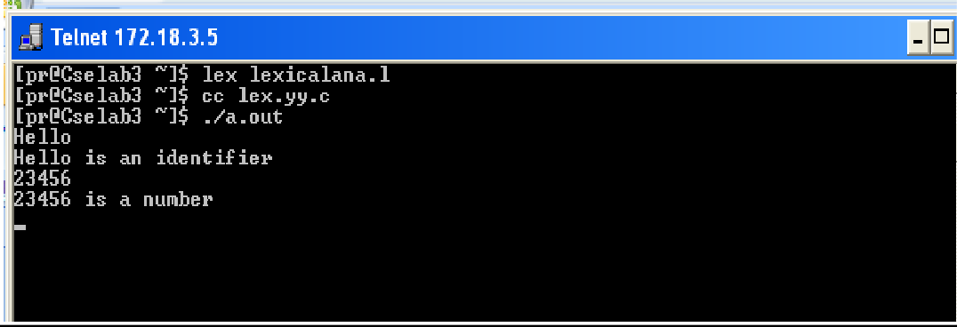

PROGRAM 2:

%{
%}
identifier [a-z|A-Z]|[a-z|A-Z|0-9]*

%%
 | #.* | {printf("\n%s is a preprocessor dir",yytext);}
 | Int | {printf("\n\t%s is a keyword",yytext);}
 | {identifier}\( | {printf("\n\nFUNCTION\n\t%s",yytext);}
 | \{ | {printf("\nBLOCK BEGINS");}
 | \} | {printf("\nBLOCK ENDS");}
 | {identifier} | {printf("\n%s is an IDENTIFIER",yytext);}
%% | . | \n

int main(int argc,char **argv)
{
if(argc>1)
{
FILE *file; file=fopen(argv[1],"r"); if(! file)
{
printf("\n couldnot open %s\n",argv[1]); exit(0);
}
yyin=file;
}
yylex();
printf("\n\n"); return 0;
}

int yywrap()
{
return 0;
}

Input ( in.c )
#include<stdio.h> main()
{
int a ;
}

OUTPUT:
RESULT:

Thus the C program for the implementation of lexical analyzer using LEX Tool was executed successfully.
23
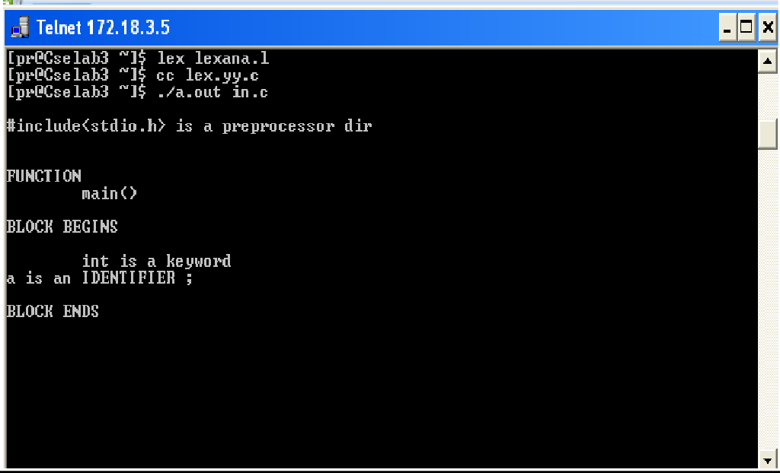

Ex. No: 4 (a)

GENERARATION OF YACC SPECIFICATION RECOGNIZING A VALID ARITHMETIC EXPRESSION
24
AIM:

To write a program to recognize a valid arithmetic expression that uses operator +, - , * and / using YACC tool.

ALGORITHM:

LEX
- Declare the required header file and variable declaration with in ‘%{‘ and ‘%}’.
- LEX requires regular expressions to identify valid arithmetic expression token of lexemes.
- LEX call yywrap() function after input is over. It should return 1 when work is done or should return 0 when more processing is required.

YACC
- Declare the required header file and variable declaration with in ‘%{‘ and ‘%}’.
- Define tokens in the first section and also define the associativity of the operations
- Mention the grammar productions and the action for each production.
- $$ refer to the top of the stack position while $1 for the first value, $2 for the second value in the stack.
- Call yyparse() to initiate the parsing process.
- yyerror() function is called when all productions in the grammar in second section doesn't match to the input statement.

PROGRAM:

//art_expr.l
%{
#include<stdio.h> #include "y.tab.h"
%}
%%
[a-zA-Z][0-9a-zA-Z]* {return ID;} [0- 9]+ {return DIG;}
[ \t]+ {;}
. {return yytext[0];}
\n {return 0;}
%%
int yywrap()
{
return 1;
}

//art_expr.y
%{
#include<stdio.h>
%}
%token ID DIG
%left '+''-'
%left '*''/'
%right UMINUS
%%
stmt:expn ;
expn:expn'+'expn
|expn'-'expn
|expn'*'expn
|expn'/'expn
|'-'expn %prec UMINUS
|'('expn')'
|DIG
|ID
25

;
26
RESULT:
Thus the program to recognize a valid arithmetic expression that uses operator +, - , * and / using YACC tool was executed and verified successfully.
%%
int main()
{
printf("Enter the Expression \n"); yyparse();
printf("valid Expression \n"); return 0;
}
int yyerror()
{
printf("Invalid Expression"); exit(0);
}

OUTPUT
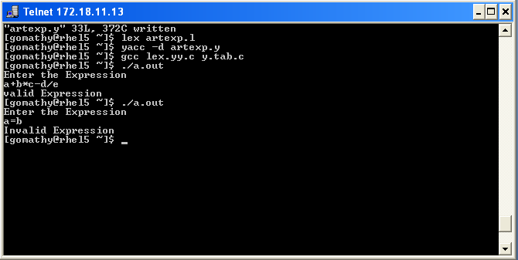

Ex. No: 4 (b)
27

RECOGNIZING A VALID VARIABLE

AIM:

To write a program to recognize a valid variable which starts with a letter followed by any number of letters or digits using YACC tool.

ALGORITHM:

LEX
- Declare the required header file and variable declaration with in ‘%{‘ and ‘%}’.
- LEX requires regular expressions or patterns to identify token of lexemes for recognize a valid variable.
- Lex call yywrap() function after input is over. It should return 1 when work is done or should return 0 when more processing is required.

YACC
- Declare the required header file and variable declaration with in ‘%{‘ and ‘%}’.
- Define tokens in the first section and also define the associativity of the operations
- Mention the grammar productions and the action for each production.
- $$ refer to the top of the stack position while $1 for the first value, $2 for the second value in the stack.
- Call yyparse() to initiate the parsing process.
- yyerror() function is called when all productions in the grammar in second section doesn't match to the input statement.

PROGRAM:

//valvar.l
%{
#include "y.tab.h"
%}
%%
[a-zA-Z] {return LET;}
[0-9] {return DIG;}
. {return yytext[0];}
\n {return 0;}
%%
int yywrap()
{
return 1;
}

//valvar.y

%{
#include<stdio.h>
%}
%token LET DIG
%%
variable:var
;
var:var DIG
|var LET
|LET
;
%%
int main()
{
printf("Enter the variable:\n"); yyparse(); printf("Valid variable \n");
28
return 0;
29
RESULT:
Thus the program to recognize a valid variable which starts with a letter followed by any number of letters or digits using YACC tool was executed and verified successfully.
}
int yyerror()
{
printf("Invalid variable \n"); exit(0);
}

OUTPUT:
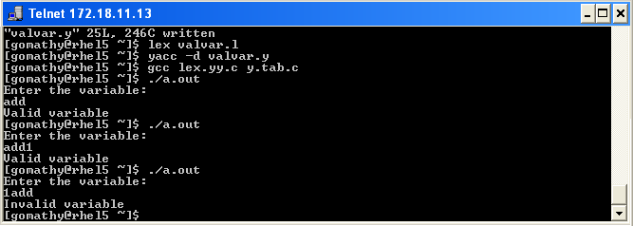

Ex.NO: 4(c)
30

IMPLEMENTATION OF CALCULATOR USING LEX AND YACC

AIM:
To write a program to implement Calculator using LEX and YACC.

ALGORITHM:

Step 1: Start the program.
Step 2: In the declaration part of lex, includes declaration of regular definitions as digit.
Step 3: In the translation rules part of lex, specifies the pattern and its action that is to be executed whenever a lexeme matched by pattern is found in the input in the cal.l.
Step 4: By use of Yacc program,all the Arithmetic operations are done such as +,-,*,/.
Step 5: Display error is persist.
Step 6: Provide the input. Step 7: Verify the output. Step 8: End.

PROGRAM:

cal.l
DIGIT [0-9]+

%option noyywrap

%%

{DIGIT} { yylval=atof(yytext); return NUM;}
\n|. { return yytext[0];}

%%

cal.y
%{

%}

#include<ctype.h> #include<stdio.h>
#define YYSTYPE double
31
%token NUM
%left ‘+’ ‘-‘
%left ‘*’ ‘/’
%right UMINUS

%%

Statment:E { printf(“Answer: %g \n”, $$); }
|Statment ‘\n’
;
E : E'+'E { $$ = $1 + $3; }
| E'-'E { $$=$1-$3; }
| E'*'E { $$=$1*$3; }
| E'/'E { $$=$1/$3; }
| NUM
;
%%

OUTPUT:
RESULT:
Thus the program for implementing calculator using LEX and YACC is executed and verified.
32

"cal2.y" 59L, 1186C written [exam01@Cselab3 ~]$ lex cal2.l [exam01@Cselab3 ~]$ yacc yaccal2.y [exam01@Cselab3 ~]$ cc y.tab.c [exam01@Cselab3 ~]$ ./a.out
Enter the expression:2+2 Answer: 4

Ex.No:5

CONVERSION OF THE BNF RULES INTO YACC FORM AND GENERATION ABSTRACT SYNTAX TREE

AIM:
To write the program to convert the BNF rules into YACC form and write code to generate abstract syntax tree.

ALGORITHM:
- Start the program.
- Reading an input file line by line.
- Convert it in to abstract syntax tree using three address codes.
- Represent three address codes in the form of quadruple tabular form.

PROGRAM:

<int.l>
%{

%}

#include"y.tab.h" #include<stdio.h> #include<string.h> int LineNo=1;
identifier [a-zA-Z][_a-zA-Z0-9]* number [0-9]+|([0-9]*\.[0-9]+)
%%

%%

<int.y>
%{
main\(\) return MAIN; if return IF;
else return ELSE; while return WHILE; int |
char |
float return TYPE;
{identifier} {strcpy(yylval.var,yytext); return VAR;}
{number} {strcpy(yylval.var,yytext); return NUM;}
\< |
\> |
\>= |
\<= |
== {strcpy(yylval.var,yytext); return RELOP;}
[ \t] ;
\n LineNo++;
. return yytext[0];

#include<string.h> #include<stdio.h> struct quad
{
char op[5]; char arg1[10]; char arg2[10]; char result[10];
}QUAD[30];
struct stack
{
int items[100]; int top;
}stk;
int Index=0,tIndex=0,StNo,Ind,tInd; extern int LineNo;
%}
%union
34

{
char var[10];
}
%token <var> NUM VAR RELOP
%token MAIN IF ELSE WHILE TYPE
%type <var> EXPR ASSIGNMENT CONDITION IFST ELSEST WHILELOOP
%left '-' '+'
%left '*' '/'
%%
PROGRAM : MAIN BLOCK
;
BLOCK : '{' CODE '}'
;
CODE: BLOCK
| STATEMENT CODE
| STATEMENT
;
STATEMENT: DESCT ';'
| ASSIGNMENT ';'
| CONDST
| WHILEST
;
DESCT: TYPE VARLIST
;
VARLIST: VAR ',' VARLIST
| VAR
;
ASSIGNMENT: VAR '=' EXPR{
strcpy(QUAD[Index].op,"="); strcpy(QUAD[Index].arg1,$3); strcpy(QUAD[Index].arg2,""); strcpy(QUAD[Index].result,$1); strcpy($
$,QUAD[Index++].result);
}
;
EXPR: EXPR '+' EXPR {AddQuadruple("+",$1,$3,$$);}
| EXPR '-' EXPR {AddQuadruple("-",$1,$3,$$);}
| EXPR '*' EXPR {AddQuadruple("*",$1,$3,$$);}
| EXPR '/' EXPR {AddQuadruple("/",$1,$3,$$);}
| '-' EXPR {AddQuadruple("UMIN",$2,"",$$);}
| '(' EXPR ')' {strcpy($$,$2);}
| VAR
| NUM
;
CONDST: IFST{
Ind=pop(); sprintf(QUAD[Ind].result,"%d",Index); Ind=pop(); sprintf(QUAD[Ind].result,"%d",Index);
}
| IFST ELSEST
;
IFST: IF '(' CONDITION ')' {
strcpy(QUAD[Index].op,"=="); strcpy(QUAD[Index].arg1,$3);
35
strcpy(QUAD[Index].arg2,"FALSE"); strcpy(QUAD[Index].result,"-1"); push(Index);
Index++;
}
BLOCK {
strcpy(QUAD[Index].op,"GOTO"); strcpy(QUAD[Index].arg1,"");
strcpy(QUAD[Index].arg2,"");
strcpy(QUAD[Index].result,"-1"); push(Index);
Index++;
};
ELSEST: ELSE{
tInd=pop(); Ind=pop(); push(tInd);
sprintf(QUAD[Ind].result,"%d",Index);
} BLOCK{
Ind=pop(); sprintf(QUAD[Ind].result,"%d",Index);
};
CONDITION: VAR RELOP VAR {AddQuadruple($2,$1,$3,$$); StNo=Index-1;
}
| VAR
| NUM
;
WHILEST: WHILELOOP{
Ind=pop(); sprintf(QUAD[Ind].result,"%d",StNo); Ind=pop(); sprintf(QUAD[Ind].result,"%d",Index);
}
;
WHILELOOP: WHILE '(' CONDITION ')' {
strcpy(QUAD[Index].op,"=="); strcpy(QUAD[Index].arg1,$3); strcpy(QUAD[Index].arg2,"FALSE"); strcpy(QUAD[Index].result,"-1"); push(Index);
Index++;
}
BLOCK {
strcpy(QUAD[Index].op,"GOTO"); strcpy(QUAD[Index].arg1,"");
strcpy(QUAD[Index].arg2,"");
strcpy(QUAD[Index].result,"-1"); push(Index);
Index++;
}
;
%%
extern FILE *yyin;
36
int main(int argc,char *argv[])
{
FILE *fp; int i; if(argc>1)
{
fp=fopen(argv[1],"r"); if(! fp)
{
printf("\n File not found"); exit(0);
}
yyin=fp;
}
yyparse();
printf("\n\n\t\t ""\n\t\t Pos Operator Arg1 Arg2 Result" "\n\t\t
");
for(i=0;i<Index;i++)
{
printf("\n\t\t %d\t %s\t %s\t %s\t
%s",i,QUAD[i].op,QUAD[i].arg1,QUAD[i].arg2,QUAD[i].result);
}
printf("\n\t\t ");
printf("\n\n"); return 0;
}
void push(int data)
{
stk.top++; if(stk.top==100)
{
printf("\n Stack overflow\n"); exit(0);
}
stk.items[stk.top]=data;
}
int pop()
{
int data; if(stk.top==-1)
{
printf("\n Stack underflow\n"); exit(0);
}
data=stk.items[stk.top--]; return data;
}
void AddQuadruple(char op[5],char arg1[10],char arg2[10],char result[10])
{
strcpy(QUAD[Index].op,op); strcpy(QUAD[Index].arg1,arg1); strcpy(QUAD[Index].arg2,arg2); sprintf(QUAD[Index].result,"t%d",tIndex++); strcpy(result,QUAD[Index++].result);
}
37
yyerror()
{
printf("\n Error on line no:%d",LineNo);
}

Input
$vi test.c main()
{
int a,b,c; if(a<b)
{
a=a+b;
}
while(a<b)
{
a=a+b;
}
if(a<=b)
{

}
else
{
}
}
c=a-b;

c=a+b;
38

OUTPUT:
RESULT:
Thus the program to convert the BNF rules into YACC forms and writes code to generate abstract syntax tree was executed successfully.

39
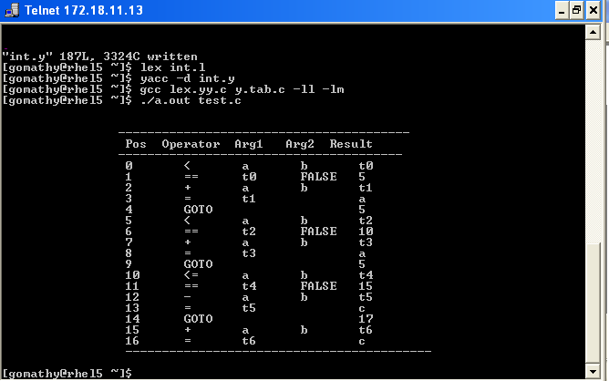

Ex.No: 6
40

IMPLEMENTATION OF TYPE CHECKING

AIM:

To write a C program to implement type checking.

ALGORITHM:

- Start the program for type checking of given expression
- Read the expression and declaration
- Based on the declaration part define the symbol table
- Check whether the symbols present in the symbol table or not. If it is found in the symbol table it displays “Label already defined”.
- Read the data type of the operand 1, operand 2 and result in the symbol table.
- If the both the operands’ type are matched then check for result variable. Else, print “Type mismatch”.
- If all the data type are matched then displays “No type mismatch”.

PROGRAM:

#include<stdio.h> #include<string.h> #include<conio.h>
int count=1,i=0,j=0,l=0,findval=0,k=0,kflag=0; char key[4][12]= {"int","float","char","double"}; char dstr[100][100],estr[100][100];
char token[100],resultvardt[100],arg1dt[100],arg2dt[100]; void entry();
int check(char[]); int search(char[]); void typecheck();
struct table
{
char var[10]; char dt[10];
};
struct table tbl[20];
void main()
{
clrscr();
printf("\n IMPLEMENTATION OF TYPE CHECKING \n");

printf("\n DECLARATION \n\n"); do
{
printf("\t");
gets(dstr[i]); i++;
} while(strcmp(dstr[i-1],"END")); printf("\n EXPRESSION \n\n"); do
{
printf("\t");
gets(estr[l]); l++;
}while(strcmp(estr[l-1],"END"));
i=0;
printf("\n SEMANTIC ANALYZER(TYPE CHECKING): \n");
while(strcmp(dstr[i],"END"))
{
entry(); printf("\n"); i++;
} l=0;
while(strcmp(estr[l],"END"))
{
typecheck(); printf("\n");
41
l++;
}
printf("\n PRESS ENTER TO EXIT FROM TYPE CHECKING\n");
getch();
}
void entry()
{
j=0; k=0;
memset(token,0,sizeof(token)); while(dstr[i] [j]!=' ')
{
token[k]=dstr[i][j]; k++;
j++;
}
kflag=check(token); if(kflag==1)
{
strcpy(tbl[count].dt,token); k=0;
memset(token,0,strlen(token)); j++;
while(dstr[i][j]!=';')
{
token[k]=dstr[i][j]; k++;
j++;
}
findval=search(token); if(findval==0)
{

}
else
{

}
strcpy(tbl[count].var,token);

printf("The variable %s is already declared",token);

}
else
{

}
kflag=0; count+
+;

printf("Enter valid datatype\n");

}
void typecheck()
{
memset(token,0,strlen(token)); j=0;
k=0;
while(estr[l][j]!='=')
42
{
token[k]=estr[l][j]; k++;
j++;
}
findval=search(token); if(findval>0)
{

}
else
{

} k=0;
strcpy(resultvardt,tbl[findval].dt); findval=0;

printf("Undefined Variable\n");
memset(token,0,strlen(token)); j+
+;
while(((estr[l][j]!='+')&&(estr[l][j]!='-')&&(estr[l][j]!='*')&&(estr[l][j]!='/')))
{
token[k]=estr[l][j]; k++;
j++;
}
findval=search(token); if(findval>0)
{

}
else
{

} k=0;
strcpy(arg1dt,tbl[findval].dt); findval=0;

printf("Undefined Variable\n");
memset(token,0,strlen(token)); j+
+;
while(estr[l][j]!=';')
{
token[k]=estr[l][j]; k++;
j++;
}
findval=search(token); if(findval>0)
{

}
else
{

}
strcpy(arg2dt,tbl[findval].dt); findval=0;

printf("Undefined Variable\n");
if(!strcmp(arg1dt,arg2dt))
{
43
if(!strcmp(resultvardt,arg1dt))
{

}
else
{
}
else
{
}
printf("\tThere is no type mismatch in the expression %s ",estr[l]);

printf("\tLvalue and Rvalue should be same\n");
printf("\tType Mismatch\n");
}
}
int search(char variable[])
{
int i; for(i=1;i<=count;i++)
{
if(strcmp(tbl[i].var,variable) == 0)
{
return i;
}
}
return 0;
}

int check(char t[])
{
int in; for(in=0;in<4;in+
+)
{
if(strcmp(key[in],t)==0)
{
return 1;
}
}
return 0;
}

OUTPUT:
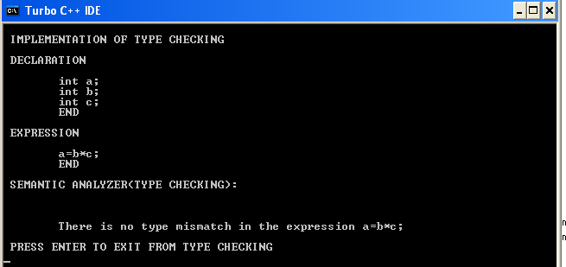

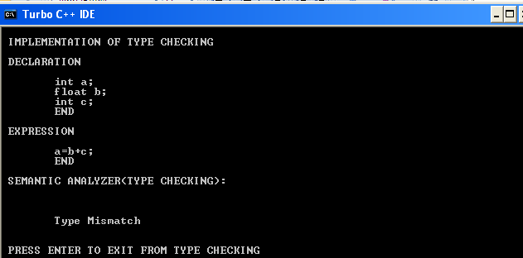

RESULT:
Thus the program for type checking is executed and verified.
45

Ex.No: 7
53
8
IMPLEMENTATION OF STACK

AIM:

To implement a storage allocation using stack.

ALGORITHM:

- Get the size of the stack.
- Read the choice of operation.
- If the choice is 1push the items into the stack
- To push the elements perform the following.
  - If the top of stack is equal to size of stack elements can’t be pushed.
  - Read item to be pushed.
  - Set or increment the top by one.
  - Assign the item to the stack [top].
  - Repeat the steps until it is required.
- If choice is 2 pop the items from the stack
  - Check for empty stack.
  - Decrement the top by one.
  - Return the popped item.
- If choice is 3 display the contents of Stack.

PROGRAM:
#include<stdio.h> #include<conio.h> #include<stdlib.h>

#define size 5 struct stack
{

} st;
int s[size]; int top;

int stfull()
{
if(st.top>=size-1) return 1;
else return 0;
}

void push(int item)
{
st.top++; st.s[st.top] = item;
}

int stempty()
{
if(st.top==-1)
return 1;
else

}

return 0;

int pop()
{
int item;
item = st.s[st.top]; st.top--;
return (item);
}

void display()
{
int i; if(stempty())
printf("\nStack Is Empty!"); else
54
{
for(i=st.top;i>=0;i--)
printf("\n%d",st.s[i]);
}
}

int main()
{
int item, choice; char ans;
st.top = -1;

printf("\n\tImplementation Of Stack"); do
{
printf("\nMain Menu");
printf("\n1.Push \n2.Pop \n3.Display \n4.exit"); printf("\ nEnter Your Choice");
scanf("%d", &choice); switch (choice)
{
case 1:

printf("\nEnter The item to be pushed"); scanf("%d", &item);
if (stfull())
printf("\nStack is Full!");

case 2:
else

push(item); break;
if(stempty())
printf("\nEmpty stack!Underflow !!");

case 3:
else
{

}
break;

item = pop();
printf("\nThe popped element is %d", item);

case 4:

}
display(); break;

exit(0);
printf("\nDo You want To Continue?"); ans=getche();
}
while(ans=='Y'||ans =='y');
return 0;
RESULT:
Thus the program for stack implementation is executed and verified.
56
}

OUTPUT:
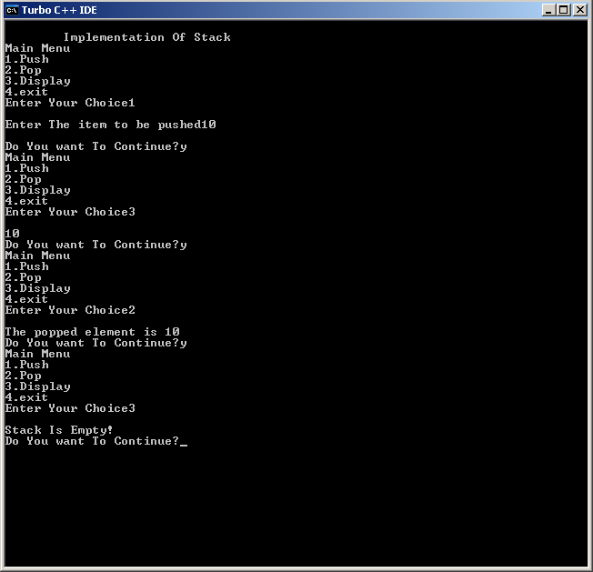

Program using LEX to count the number of characters, words, spaces and lines in a given file or program.
%{
int ch=0, bl=0, ln=0, wr=0;
%}
%%
[\n] {ln++;wr++;}
[\t] {bl++;wr++;}
[" "] {bl++;wr++;}
[^\n\t] {ch++;}
%%
int main()
{
FILE *fp; char file[10];
printf("Enter the filename: "); scanf("%s", file);
yyin=fp; yylex();
printf("Character=%d\nBlank=%d\nLines=%d\nWords=%d", ch, bl, ln, wr); return 0;
}

Output
$cat > input Girish rao salanke

$lex p1a.l
$cc lex.yy.c –ll
$./a.out
Enter the filename: input Character=16
Blank=2 Lines=1 Word=3

Write a ‘C’ program to implement lexical analyzer using c program.

#include<string.h> #include<ctype.h> #include<stdio.h>
void keyword(char str[10])
{
if(strcmp("for",str)==0||strcmp("while",str)==0||strcmp("do",str)==0|| strcmp("int",str )== 0 || strcmp("float",str)==0||strcmp("char",str)==0||strcmp("double",str)==0|| strcmp("static",str)== 0|| strcmp("switch",str)==0||strcmp("case",str)==0)
printf("\n%s is a keyword",str); else
printf("\n%s is an identifier",str);
}
int main()
{
FILE *f1,*f2,*f3; char c,str[10],st1[10]; int
num[100],lineno=0,tokenvalue=0,i=0,j=0,k=0; printf("\nEnter the c Program: ");/*gets(st1);*/ f1=fopen("input","w"); while((c=getchar())!
=EOF)
putc(c,f1); fclose(f1); f1=fopen("input","r");
f2=fopen("identifier","w"); f3=fopen("specialchar","w"); while((c=getc(f1))!=EOF)
{
if(isdigit(c))
{
tokenvalue=c-'0'; c=getc(f1); while(isdigit(c))
{
tokenvalue*=10+c-'0'; c=getc(f1);
}
num[i++]=tokenvalue; ungetc(c,f1);
}
else if(isalpha(c))
{
putc(c,f2);

Downloaded by Kalyani Mantramurthi (kalyanimantramurthi@gmail.com)
c=getc(f1); while(isdigit(c)||isalpha(c)|| c=='_'||c=='$')
{
putc(c,f2); c=getc(f1);
}
putc(' ',f2); ungetc(c,f1);
}
else if(c==' '||c=='\t') printf(" ");
else if(c=='\n') lineno++;
else
putc(c,f3);
}
fclose(f2); fclose(f3); fclose(f1);
printf("\nThe no's in the program are"); for(j=0; j<i; j++)
printf("%d",num[j]); printf("\n"); f2=fopen("identifier","r"); k=0;
printf("The keywords and identifiersare:"); while((c=getc(f2))!=EOF)
{
if(c!=' ')
str[k++]=c; else
{
str[k]='\0'; keyword(str); k=0;
}
}
fclose(f2); f3=fopen("specialchar","r"); printf("\nSpecial characters are"); while((c=getc(f3))!=EOF)
printf("%c",c);
printf("\n"); fclose(f3);
printf("Total no. of lines are:%d",lineno); return 0;

Output:
Enter the c Program: a+b*c
^Z

The no's in the program are
The keywords and identifiers are:
a is an identifier
b is an identifier
c is an identifier
Special characters are+* Total no. of lines are:1

- Write recursive descent parser for the grammar E->E+T E->T T->T*F T-
>F F->(E)/id.

#include <stdio.h> #include <string.h>

#define SUCCESS 1
#define FAILED 0
int E(), Edash(), T(), Tdash(), F(); const char *cursor;
char string[64];

int main()
{
puts("Enter the string"); scanf("%s", string);
//sscanf("i+(i+i)*i", "%s", string); cursor = string;
puts("");
puts("Input Action");
puts(" ");

if (E() && *cursor == '\0') {
puts(" ");
puts("String is successfully parsed"); return 0;
} else {
puts(" ");
puts("Error in parsing String"); return 1;
}
}

int E()
{
printf("%-16s E -> T E'\n", cursor); if (T()) {
if (Edash())
return SUCCESS; else
return FAILED;
} else
return FAILED;

}

int Edash()
{
if (*cursor == '+') {
printf("%-16s E' -> + T E'\n", cursor); cursor++;
if (T()) {
if (Edash())
return SUCCESS; else
return FAILED;
} else
return FAILED;
} else {
printf("%-16s E' -> $\n", cursor); return SUCCESS;
}
}

int T()
{
printf("%-16s T -> F T'\n", cursor); if (F()) {
if (Tdash())
return SUCCESS; else
return FAILED;
} else
return FAILED;
}

int Tdash()
{
if (*cursor == '*') {
printf("%-16s T' -> * F T'\n", cursor); cursor++;
if (F()) {
if (Tdash())
return SUCCESS; else
return FAILED;
} else
return FAILED;
} else {
printf("%-16s T' -> $\n", cursor);

Downloaded by Kalyani Mantramurthi (kalyanimantramurthi@gmail.com)
return SUCCESS;
}
}

int F()
{
if (*cursor == '(') {
printf("%-16s F -> ( E )\n", cursor); cursor+
+;
if (E()) {
if (*cursor == ')') { cursor++;
return SUCCESS;
} else
return FAILED;
} else
return FAILED;
} else if (*cursor == 'i') { cursor+
+;
printf("%-16s F ->i\n", cursor); return SUCCESS;
} else
return FAILED;
}

OUTPUT
Enter the string i+i*i

Input Action

i+i*i E -> T E'
i+i*i T -> F T'
+i*i F ->i
+i*i T' -> $
+i*i E' -> + T E'
i*i T -> F T'
*i F ->i
*i T' -> * F T' F ->i
T' -> $
E' -> $

String is successfully parsed

Write recursive descent parser for the grammar S->(L) S->a L->L, S L->S
#include <stdio.h> #include <stdlib.h> #include <ctype.h> #include <string.h>
char *input; // Pointer to the current position in the input char currentChar; // Current character being processed
// Function prototypes void parseS();
void parseL();
void match(char expected);

// Entry point int main() {
char buffer[100];
printf("Enter the input string: "); fgets(buffer, sizeof(buffer), stdin); input = buffer;
// Remove newline character if present input[strcspn(input, "\n")] = '\0';
currentChar = *input; parseS();
if (currentChar == '\0') {
printf("Input is valid according to the grammar.\n");
} else {
printf("Error: Unexpected characters at the end.\n");
}
return 0;
}

// Match the expected character void match(char expected) {
if (currentChar == expected)
{ currentChar = *++input;
} else {
printf("Error: Expected '%c' but found '%c'\n", expected, currentChar); exit(1);
}
}

// Parse S → ( L ) | a void parseS() {
if (currentChar == '(') { match('(');
parseL(); match(')');

Downloaded by Kalyani Mantramurthi (kalyanimantramurthi@gmail.com)
} else if (currentChar == 'a') { match('a');
} else {
printf("Error: Invalid start of S.\n"); exit(1);
}
}
// Parse L → L , S | S void parseL() {
parseS(); // Parse the first S
// Check for the optional ', S' part if (currentChar == ',') {
match(','); parseS();
// Handle multiple S separated by commas while (currentChar == ',') {
match(','); parseS();
}
}
}

OUTPUT
Enter the input string: (a,a,a)
Input is valid according to the grammar.

- Write a C program to calculate first function for the grammarE->E+T E-
>T T->T*F T->F F->(E)/id

#include<stdio.h> #include<ctype.h> #include<string.h>

// Functions to calculate Follow void followfirst(char, int, int); void follow(char c);

// Function to calculate First void findfirst(char, int, int);

int count, n = 0;

// Stores the final result
// of the First Sets
char calc_first[10][100];

// Stores the final result
// of the Follow Sets
char calc_follow[10][100]; int m = 0;

// Stores the production rules char production[10][10]; char f[10], first[10];
int k; char ck; int e;

int main(int argc, char **argv)
{
int jm = 0; int km = 0; int i, choice; char c, ch; count = 8;

strcpy(production[0], "E=TR"); strcpy(production[1], "R=+TR"); strcpy(production[2], "R=#"); strcpy(production[3], "T=FY"); strcpy(production[4], "Y=*FY"); strcpy(production[5], "Y=#");

Downloaded by Kalyani Mantramurthi (kalyanimantramurthi@gmail.com)
strcpy(production[6], "F=(E)"); strcpy(production[7], "F=i");

int kay;
char done[count]; int ptr = -1;

// Initializing the calc_first array for(k = 0; k < count; k++) {
for(kay = 0; kay < 100; kay++)
{ calc_first[k][kay] = '!';
}
}
int point1 = 0, point2, x;

for(k = 0; k < count; k++)
{
c = production[k][0]; point2 = 0;
x = 0;

// Checking if First of c has
// already been calculated for(kay = 0; kay <= ptr; kay++)
if(c == done[kay])
x = 1;

if (x == 1)
continue;

// Function call findfirst(c, 0, 0);
ptr += 1;

// Adding c to the calculated list done[ptr] = c;
printf("\n First(%c) = { ", c); calc_first[point1][point2++] = c;

// Printing the First Sets of the grammar for(i = 0 + jm; i < n; i++) {
int lark = 0, chk = 0;

for(lark = 0; lark < point2; lark++) {

if (first[i] == calc_first[point1][lark])

{
chk = 1; break;
}
}
if(chk == 0)
{
printf("%c, ", first[i]); calc_first[point1][point2++] = first[i];
}
}
printf("}\n"); jm = n; point1++;
}
printf("\n");
printf(" \n\n");
char donee[count]; ptr = -1;

// Initializing the calc_follow array for(k = 0; k < count; k++) {
for(kay = 0; kay < 100; kay++)
{ calc_follow[k][kay] = '!';
}
}
point1 = 0; int land = 0;
for(e = 0; e < count; e++)
{
ck = production[e][0]; point2 = 0;
x = 0;

// Checking if Follow of ck
// has alredy been calculated for(kay = 0; kay <= ptr; kay++)
if(ck == donee[kay]) x = 1;

if (x == 1)
continue; land += 1;

// Function call follow(ck);

Downloaded by Kalyani Mantramurthi (kalyanimantramurthi@gmail.com)
ptr += 1;

// Adding ck to the calculated list donee[ptr] = ck;
printf(" Follow(%c) = { ", ck); calc_follow[point1][point2++] = ck;

// Printing the Follow Sets of the grammar for(i = 0 + km; i < m; i++) {
int lark = 0, chk = 0;
for(lark = 0; lark < point2; lark++)
{
if (f[i] == calc_follow[point1][lark])
{
chk = 1; break;
}
}
if(chk == 0)
{
printf("%c, ", f[i]); calc_follow[point1][point2++] = f[i];
}
}
printf(" }\n\n"); km = m; point1+
+;
}
}

void follow(char c)
{
int i, j;

// Adding "$" to the follow
// set of the start symbol if(production[0][0] == c) {
f[m++] = '$';
}
for(i = 0; i < 10; i++)
{
for(j = 2;j < 10; j++)
{
if(production[i][j] == c)
{
if(production[i][j+1] != '\0')

{
// Calculate the first of the next
// Non-Terminal in the production followfirst(production[i] [j+1], i, (j+2));
}

if(production[i][j+1]=='\0' && c!=production[i][0])
{
// Calculate the follow of the Non-Terminal
// in the L.H.S. of the production follow(production[i][0]);
}
}
}
}
}

void findfirst(char c, int q1, int q2)
{
int j;

// The case where we
// encounter a Terminal if(! (isupper(c))) {
first[n++] = c;
}
for(j = 0; j < count; j++)
{
if(production[j][0] == c)
{
if(production[j][2] == '#')
{
if(production[q1][q2] == '\0') first[n+
+] = '#';
else if(production[q1][q2] != '\0'
&& (q1 != 0 || q2 != 0))
{

}
else

}

// Recursion to calculate First of New
// Non-Terminal we encounter after epsilon findfirst(production[q1][q2], q1, (q2+1));

first[n++] = '#';
else if(!isupper(production[j][2]))
{

Downloaded by Kalyani Mantramurthi (kalyanimantramurthi@gmail.com)
}
else
{

}
}
}
}
first[n++] = production[j][2];

// Recursion to calculate First of
// New Non-Terminal we encounter
// at the beginning findfirst(production[j][2], j, 3);

void followfirst(char c, int c1, int c2)
{
int k;

// The case where we encounter
// a Terminal if(! (isupper(c)))
f[m++] = c;
else
{

int i = 0, j = 1;
for(i = 0; i < count; i++)
{
if(calc_first[i][0] == c) break;
}

//Including the First set of the
// Non-Terminal in the Follow of
// the original query while(calc_first[i][j] != '!')
{
if(calc_first[i][j] != '#')
{

}
else
{
f[m++] = calc_first[i][j];

if(production[c1][c2] == '\0')
{
// Case where we reach the
// end of a production follow(production[c1]

} j+
+;
}
}
}
}
else
{

}

// Recursion to the next symbol
// in case we encounter a "#" followfirst(production[c1] [c2], c1, c2+1);

Output:

First(E) | = | { | (, | i, | }
First(R) | = | { | +, | #, | }
First(T) | = | { | (, | i, | }
First(Y) | = | { | *, | #, | }
First(F) | = | { | (, | i, | }

Follow(E) | = | { | $, | ), | }
Follow(R) | = | { | $, | ), | }
Follow(T) | = | { | +, | $, | ), | }
Follow(Y) | = | { | +, | $, | ), | }
Follow(F) | = | { | *, | +, | $, | ), }

Downloaded by Kalyani Mantramurthi (kalyanimantramurthi@gmail.com)

Write a YACC program to implement a top down parser for the given grammar. Grammar
E -> E + T | E - T | T
T -> T * F | T / F | F F -> ( E ) | id | num Program:
%{
#include <stdio.h> #include <stdlib.h> #include <ctype.h>

int yylex(void);
void yyerror(const char *s);
%}

%token ID NUM
%left '+' '-'
%left '*' '/'

%%

program:
expression '\n' { printf("Result: %d\n", $1); }
;

expression:
expression '+' term { $$ = $1 + $3; }
| expression '-' term { $$ = $1 - $3; }
| term { $$ = $1; }
;

term:
term '*' factor { $$ = $1 * $3; }
| term '/' factor { $$ = $1 / $3; }
| factor { $$ = $1; }
;

factor:
'(' expression ')' { $$ = $2; }
| ID { $$ = 1; } // Simplified: assume ID = 1
| NUM { $$ = $1; }
;

%%

int main(void) {
printf("Enter an expression:\n"); yyparse();
return 0;
}

void yyerror(const char *s)
{ fprintf(stderr, "Error: %s\n", s);
}

int yylex(void)
{ int c = getchar();
while (isspace(c)) c = getchar();

if (isdigit(c))
{ ungetc(c, stdin);
scanf("%d", &yylval); return NUM;
}

if (isalpha(c))
{ yylval = c; return ID;
}

if (c == '+' || c == '-' || c == '*' || c == '/' || c == '(' || c == ')' || c == '\n')
{ return c;
}

return 0; // End of input
}

How to Compile and Run:

- Save the code to a file, e.g., parser.y.
- Run yacc -d parser.y to generate the parser.
- Compile with gcc y.tab.c -o parser -ly -ll.
- Run the parser: ./parser.

Example Input: 3 + 4 * 5

Downloaded by Kalyani Mantramurthi (kalyanimantramurthi@gmail.com)

